Hitchhiker’s Guide to UEB

2013 update

Printing and Binding Instructions

For the Print Version

The Hitchhikers Guide to UEB is saved as two separate files.
- Hitchhikers Guide Literary Oct 2013
- Hitchhikers Guide Maths Oct 2013

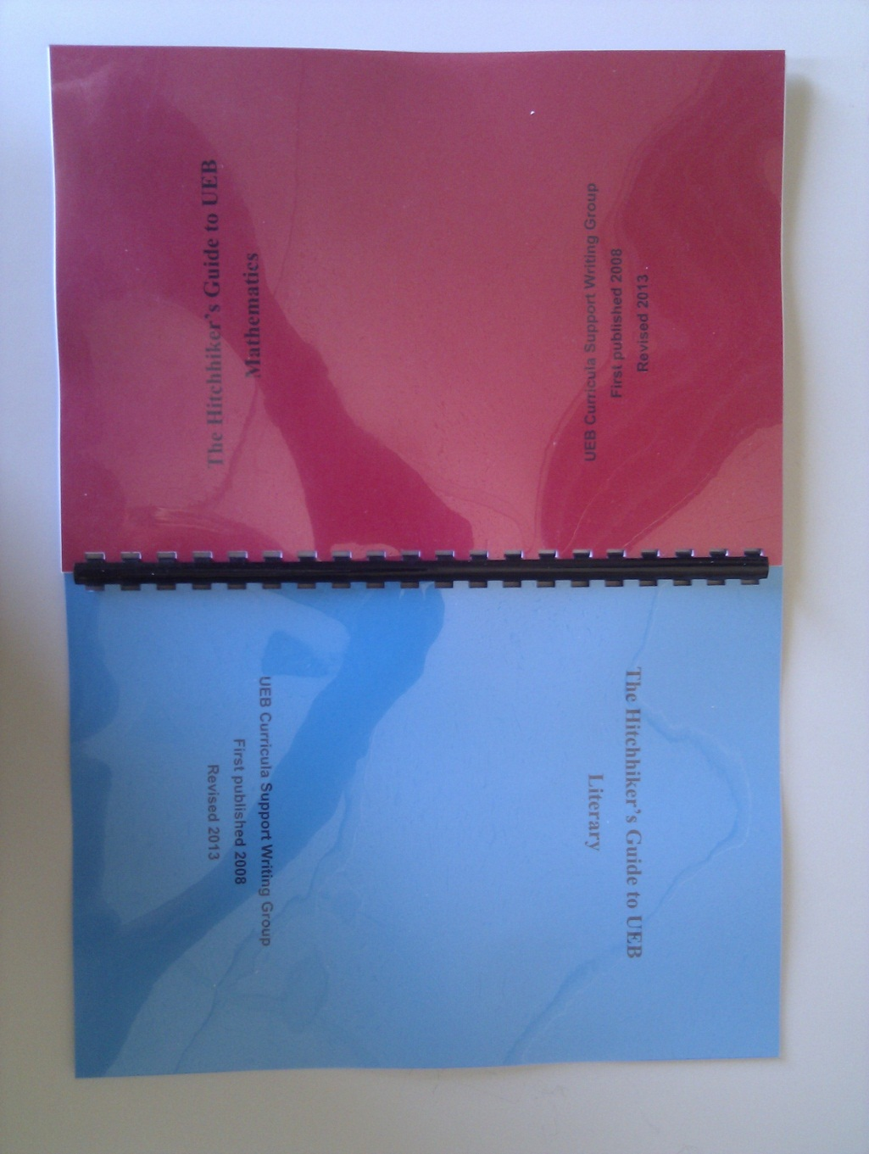
These can be printed separately but should be bound together back to back. The front and back covers should be different colours. The photograph below shows how the book should look after binding.

This design means that the user can open the book from the front or the back with instant access to the maths content from one end and the literary content from the other end. A third coloured page can be used in the centre between the last page of the maths section and the last page of the literary section.

The first two pages of each file will need printing onto the front and back of the coloured covers. Having the contents on the back of the cover gives instant access to the quick reference page at both ends of the book.

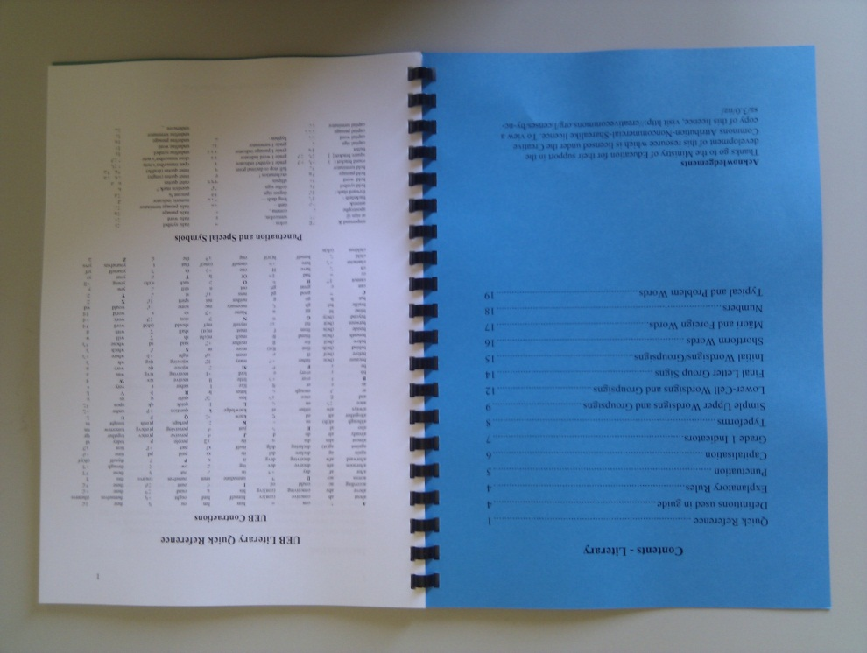

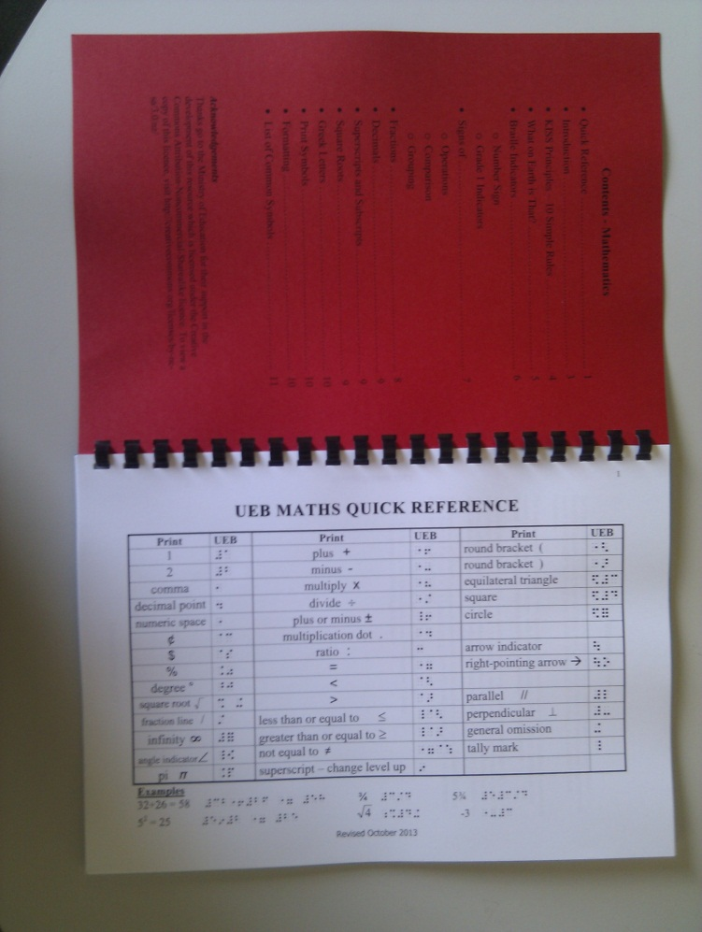

The braille version is in three volumes and these should be bound in the usual way.

