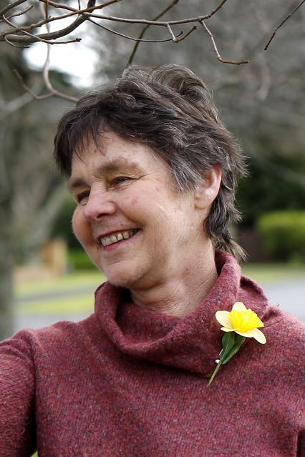
Stephanie Conn
On the 4th May 1998 Stephanie began working for the RNZFB, Transcription services as a Braille producer. Over the next 12½ years she mastered the braille literary code, textbook code, the Nemeth code and produced a large number of tactile graphics. Stephanie’s work was always meticulous.
Diagram production using the thermoform method requires lots of patience, attention to detail and an understanding of what will and won’t work for the students. Stephanie’s experience as a teacher, and her knack of how to size diagrams, graphs and maps and provide enough detail to enable the student to answer questions was greatly valued by us all.
Her ability to look at a picture and compile a succinct transcriber’s note, giving enough information, but not the actual answer, to be used in examination situations was recognized by other producers who often sought out assistance when needed.

Braille Materials Transcribed by Stephanie Conn: In those years Stephanie transcribed 904 titles made up of 1515 volumes. She produced 56,689 braille pages which include 8,140 tactile diagrams. Many of the school text books and diagrams are still in use, and being repeated as students require them.
She served as a member on the Nemeth Code Committee, assisted with copyholding and could always be relied upon to give clear and accurate responses to braille queries.
One year she and her husband Stewart catered a Hangi for her colleagues, and her love of family shone through as she shared milestones in her sons’ lives.
In 1999 when the decision was made that Transcription Services should be shifted from Manurewa in to Newmarket, Stephanie was key to negotiations with management to ensure that a fair deal was agreed upon for those staff affected by the move.
Once settled in to the new work area, Stephanie’s love of walking was evidenced, as every day at lunchtime you would find many of the braille team exploring walking paths and tracks around Newmarket. As a treat, every second Friday, a new lunch bar or eating establishment was located and food quality tested.
When her illness was diagnosed and future treatment agreed by health professionals and her family, Stephanie continued working as a braille producer, moving between work and home, where an office was set up to enable her to continue right up until ten days before she slipped away.
The passion and excitement she shared when her sons married and then the birth of grandchildren was wonderful to see and be a part of. The no-nonsense, common sense, calm way Stephanie dealt with her illness, work and family commitments was humbling and made you appreciate how precious life is.
The Royal New Zealand Foundation of the Blind, teachers, students and colleagues would like to acknowledge Stephanie's dedicated service to visually impaired New Zealanders over the years.
We are the richer for having known her with the legacy living on through family, friends and the braille she produced for upcoming students.

