The Braille Authority of New Zealand Aotearoa Trust

22 September 2025

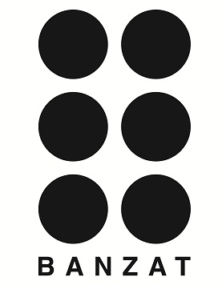

# Call for Applications to be an Accredited Individual Braille Producer

The Braille Authority of New Zealand Aotearoa Trust (BANZAT) invites applications to become an Accredited Individual Braille Producer. For this round, applications close on 30 November 2025.

Braille is the primary literacy and numeracy medium for people who are blind, deafblind or have low vision. One of BANZAT's purposes is to accredit individual Braille producers in New Zealand who are not already working in Braille production at BLVNZ or BLENNZ.

You need to have passed the Trans-Tasman Certificate of Proficiency in Unified English Braille before you can become an accredited individual Braille producer. Trustees need to see examples of your Braille production work. We will check the samples of your work against BANZAT's standards:

• The Rules of Unified English Braille, Third Edition, 2024, see <https://iceb.org/ueb.html#Rulebook>;

• Essentials of Braille Formatting, see <https://www.banzat.org.nz/publications/braille-codes-and-formats>and

• Policy 7 Accreditation of Braille Producers Working in Aotearoa New Zealand, see <https://www.banzat.org.nz/publications/policies>.

Information about what we are looking for in your samples of Braille and the Application Form are in Policy 7. Applications for individual producers close for this round on 30 November 2025.

If you have any questions, please contact Maria Stevens, email <chair@banzat.org.nz> or Mary Schnackenberg, email <secretary@banzat.org.nz>

You can phone Mary on 0800 BANZAT (0800 226928)

We look forward to receiving your application.

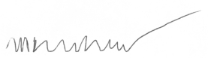

Mary Schnackenberg

Secretary/Treasurer

The Braille Authority of New Zealand Aotearoa Trust

Email: <secretary@banzat.org.nz>

Phone: 0800 BANZAT (0800 226928) | Mobile +64 21 983 652

Website: <https://www.banzat.org.nz/>

To join the New Zealand Braille email discussion list send a blank message to nzbrl+subscribe@groups.io

The Braille Authority of New Zealand Aotearoa Trust is a registered charitable entity <https://www.charities.govt.nz> Number CC45306.

“BANZAT Building Better Braille”